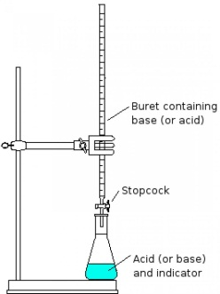
Titrations- 3 ways to solve Name: ___________________________

- Using Ms. Rousseau’s shortcut equation
- Using mostly factor/label
- Using mostly formulas

- It is found that 25.00 mL of 0.100M sulphuric acid is required to neutralize 15.00 mL of an unknown concentration of potassium hydroxide. Determine the concentration of the hydroxide using the 3 methods above.

A-

B-

C-

- When using a burette, a student discovers that it takes 35.00mL of a 0.250M solution of sodium hydroxide to neutralize 25.00mL of an unknown concentration of phosphoric acid. It is at this point that the indicator, phenolphthalein turns from colorless to light pink. Determine the concentration of the unknown acid using all three methods.

Which method is your favorite and why? Which do you find the hardest and why?

