SCH3U1

Acid/Base Reactions and Titrations

ACID + BASE SALT + WATER

BCE:

NIE:

TIE:

ACID + CARBONATE SALT + CARBON DIOXIDE + WATER

BCE:

TITRATION is the process of determining the concentration of an acidic or basic solution by reacting it with a solution of a known concentration. To determine the unknown concentration, we must measure the volume of acid or base carefully using a burette (see figure). By recording the initial volume and final volume, the volume of solution added can be easily measured. 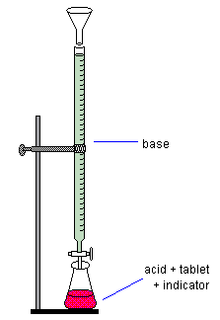 usually: analyte is in the Erlenmeyer flask
titrant (standard) is in the burette

The end point of the reaction is detected with an indicator such as phenolphthalein. The compound turns pink close to neutral pH, when all the acid or base present has been neutralized; the equivalence point.
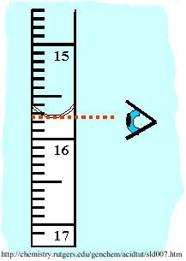
Example 1: Titration of a Strong Acid with a Strong Base
A 10.00 mL solution of hydrochloric acid
was titrated with 0.225 mol/L sodium hydroxide.
The following data was collected:

V_{initial} = 12.45 mL
V_{final} = _____
V_{added} = V_{final} – V_{initial} = ________

What is the concentration of the hydrochloric acid solution?

Solution:
Acid-base titration questions can be solved using stoichiometry.

To solve this acid-base titration question:

- Write a balanced chemical equation for the neutralization reaction.
- Calculate the number of moles of base used in the titration (n = c⋅V)
- Using mole rations, determine the number of moles of acid that reacted.
- Calculate the concentration of the unknown acid solution (c = n / V)

e.g.1
Titration of a Strong Acid with a Strong Base
A 10.00 mL solution of hydrochloric acid was titrated with 0.225 mol/L sodium hydroxide. The following data was collected:

V_{initial} = 12.45 mL
V_{final} = 15.75 mL
V_{added} = V_{final} – V_{initial} = 3.30 mL

BCE: HCl (aq) + NaOH (aq) NaCl (aq) + H₂O

C_{acid} = ? c_{base} = 0.225 mol/L
V_{acid} = 10.00 mL = 0.01000 L V_{base} = 3.30 mL = 0.00330 L

Moles Base: n = cV = (0.00330mol/L)(0.225L) = 7.425 x 10⁻⁴ mol

Mole Ratio: n_{acid} = n_{base} = 7.425 x 10⁻⁴ mol

Concentration of Acid: c = n/V = (7.425 x 10⁻⁴ mol)/(0.01000L) = 0.0742 mol/L

Therefore the concentration of acid was 0.0742 mol/L.

e.g.2
Titration of a Strong Base with a Diprotic Acid (H₂X)
What volume of 0.159 mol/L KOH solution would be required to neutralize 27.48 mL of 0.104 mol/L H₂SO₄?

BCE: H₂SO_{4 (aq)} + 2 KOH _{(aq)} K₂SO_{4 (aq)} + 2H₂O

C_{acid} = 0.104 mol/L c_{base} = 0.159 mol/L
V_{acid} = 27.48 mL = 0.02748 L V_{base} = ?

Moles Acid: n_{acid} = cV = (0.104)(0.02748) = 0.002858 mol

Mole Ratio n_{acid} = 1
n_{base} 2

n_{base} = 2 x n_{acid} = (2) (0.002858) = 0.005716 mol

Volume of Base Needed: V = n/c = 0.005716 / 0.159 = 0.035948 L

V = 35.9 mL (to 3 significant digits)

Therefore 35.9 mL of the KOH base is needed to neutralize the acid.
e.g. 3
Cleaning up Acid Spills
What mass of sodium hydrogen carbonate is needed to clean up a 250 mL spill of concentrated hydrofluoric acid (27.6 mol/L)?

BCE: NaHCO_{3 (s)} + HF _{(aq)} NaF _{(aq)} + H₂O + CO_{2 (g)}

Moles Acid:: n_{acid} = cV = (27.6 mol/L)(0.250 L) = 6.90 mol

Mole ratio: n_{acid} = n_{base} = 6.90 mol

Moles to Mass: m = nM = (6.90 mol)(84.01 g/mol) = 580 g
Therefore 580 g of the sodium hydrogen carbonate is required for the clean-up.

