GRADE 10 SNC2D - BIOLOGY UNIT REVIEW Name: _____Answer Key_________________
1. a) State Cell Theory:
- A cell is the basic unit of life
- Everything is made up of cells
- All cells come from pre-existing cells
b) How can you tell the difference between an animal and plant cell? What would you look for?
- Animal cells are circular in shape and plant cells are rectangular. Plant cells have chloroplasts and a cell wall while animal cells do not.
2. a) Label the following diagrams below.
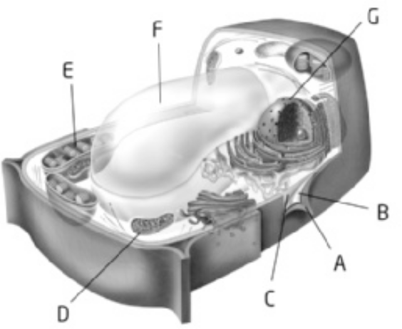
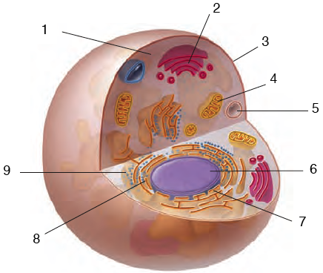

b) | Structure | Function
Cytoplasm | C, 1 | The medium that holds organelles, nutrients and water to the cell
Cell wall | A | Provides a rigid structure for the plant cell and support
Cell membrane | B, 3 | Surrounds the cells internal cell parts, controls what is allowed to go in and out of the cell
Nucleus | G, 6 | Contains DNA, control system (brain)
Endoplasmic reticulum | 7, 8 | Transports proteins, connected to the nucleus
Golgi bodies | 9 | Transports proteins out of the cell
Vacuoles | F, 5 | Stores water and minerals needed for the cell to live
Chloroplast | E | Photosynthesis takes place here = glucose

c) What structures can you find in plants that you cannot find in animals?
Plants only | Animals only
Cell wall
Chloroplasts
Cell plate (mitosis) | Cilia
One big vacuole | Many vacuoles

3. What are the 3 reasons why cells divide?
a) growth
b) repair
c) reproduce
4. What is the difference between osmosis and diffusion? Where does diffusion occur within the cell? Where does diffusion occur within the body?
Osmosis – movement of the solvent which is water molecules
Diffusion – is the movement of particles (solute) from high concentrations to low concentration.
Diffusion takes place at the cell membrane.
Where alveoli and capillaries meet oxygen and carbon dioxide are exchanged due to diffusion. (Respiratory and circulatory systems)
5. What is a tumour?
A tumour is a group of cells (UNCONTROLABLLY) that increase in number that do not have a benefit to the body.
Benign (non cancerous) and malignant (cancerous)
6. What is cancer? List substances/factors that can cause cancer. List factors that can help prevent cancer.
Cell multiple nuclei – to many brains
Smoking, UV radiation, food with GMOS, carcinogens (chemicals)
Exercise, eat healthy (fruits and veggies), stay out of the sun, monitor our body
7. Identify the phases and mitosis and write a description of the key events that occur during that phase
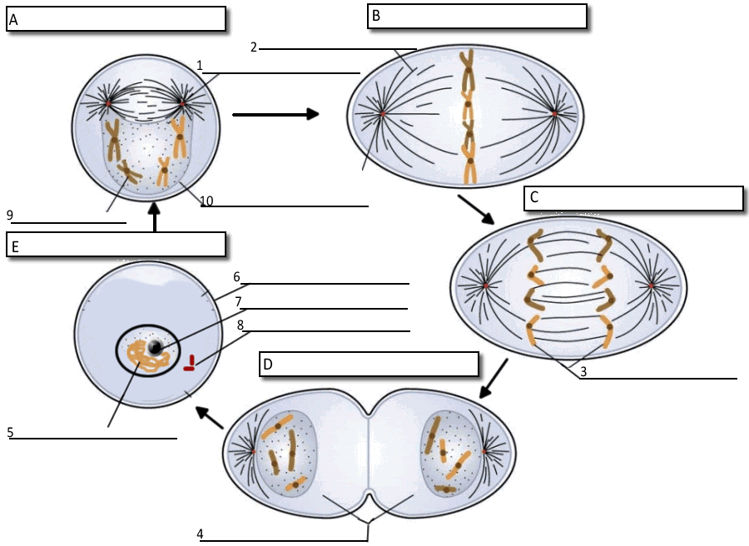

What happens during each phase?
Phase | Description of what happens
Interphase | - The longest of all 3 stages of the cell cycle  - The cell grows and prepares to divide by duplicating its DNA and organelles so that it can be shared between the 2 new cells.  - The DNA strands, chromosomes copy themselves, they are now identical strands of DNA  - This now allows for the new cell to have the same genetic information as the parent cell.
Prophase | - Chromosomes thicken and become more visible bodies, each pair is made up of identical strands.  - Nucleolus disappears  - Nuclear membrane around the nucleus begins to dissolve.  - 2 centrioles move to opposite ends of the cell  - Mesh-like spindle fibres form between centrioles  - Chromosomes begin to attach to spindle fibres.
Metaphase | - Chromosomes attached to spindle fibers line up in the middle (the equator) of the cell  - Spindle fibers attach to the centromeres of the chromosomes.
Anaphase | - The sister chromatids separate and are pulled to opposite poles of the cell.  - Each separate chromatid is called a daughter chromosome.  - One complete set of chromosomes moves to each end of the cell.
Telophase/Cytokinesis | - Spindle fibres begin to disappear  - Daughter chromosomes stretch out, and become thin and invisible again.  - A new nuclear membrane begins to form around the nucleus at each end of the cell.  - There are now 2 separate nuclei and the cell is ready to split into 2  - In this last stage of the cell cycle, the cytoplasm and other organelles are distributed to the two ends of the cell.  - In an animal cell the cell membrane pinches in called the cleavage furrow.  - This separates the dividing cell into 2 new daughter cells.  - Each daughter cell has a nucleus with a complete copy of the parents cell’s DNA and its own organelles.
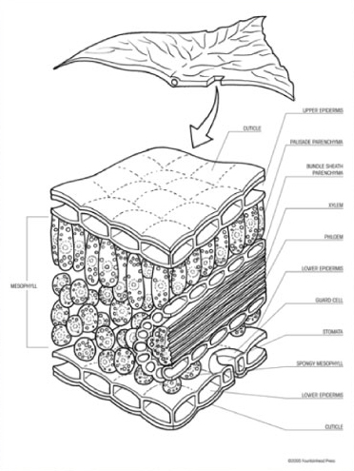
8. How is cytokinesis different in plants and animals?
Cytokinesis does not occur, instead a cell plate is formed during telophase and extends to the sides eventually forming a new cell wall. This splits the original parent cell into 2 daughter cells.
9. a) What are stem cells? How are they controversial?
An unspecialized cell that can become any type of cell in the body.
b) What is a meristem? Why is a meristem important?
An unspecialized cell that is found only in plant cells that can give rise to specialized cells

c) Label the diagram of the leaf found to the right.
10. Draw a plant. Label the four organs of the plant. Root, stem, leaves and flower (not all plants)
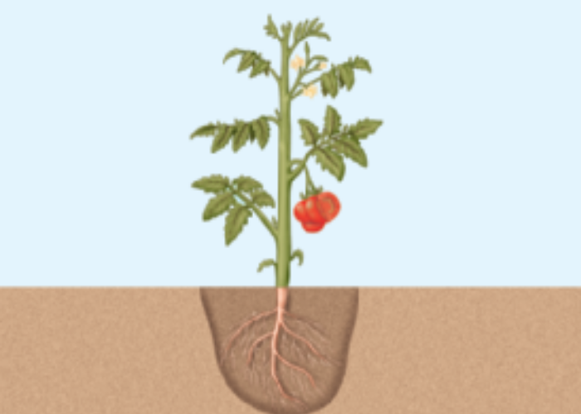
11.Explain the difference between fibrous roots and tap roots.

Fibrous Root
- spread out horizontally near the surface
- stabilizes soil and prevents erosion and landslides

Tap Root
- one main root that grows larger and thicker than the rest
- anchors the plant firmly in the ground

12.Explain the process of transpiration
The evapouration of water from the leaves of a plant.
- What enters and exits through the stomata?
Water and gases (carbon dioxide, oxygen and water), the stoma is a plant leaf pore.
- What do guard cells do?
Guard cells change their shape and control the opening and closing of the stomata.
- What is photosynthesis? Where does photosynthesis occur?

6CO₂ + 6 H₂O + energy → C₆H₁₂O₆ (glucose) + 6O_{2,} it takes place in the chloroplasts

16. What is the hierarchy of cells? Give a specific example from one of the systems studied.
Cell → tissue → organ → organ system → organism
Example: cell → muscle tissue → heart → circulatory system → human

17. Label the diagram below in the spaces provided.
A _____mouth______________
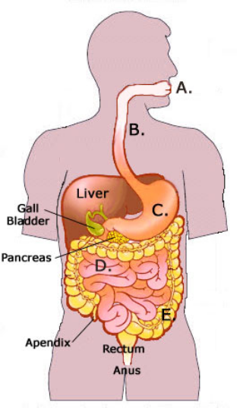

B _____esophagus___________

C _____stomach____________

D ____small intestine________

E ____large intestine________
18. Identify the four tissue types. Write their structure, function and examples in the chart.
Picture | Tissue type & example | Structure | Function
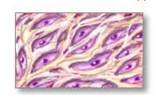 | Connective tissue | Bones  blood | Cells held together by a liquid or solid matrix for support and insulation
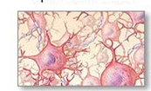 | Nerve tissue | Nerves  Brain  Spinal Cord | Cells that conduct electrical pulses for sensory, communication and coordination
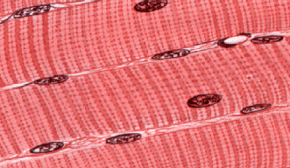 | Muscle Tissues | Legs  Arms | Bundles of long cells that can shorten and contract to help movement
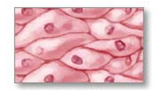 | Epithelial tissues | Skin  lungs | Sheets of lightly packed cells for protection and lining
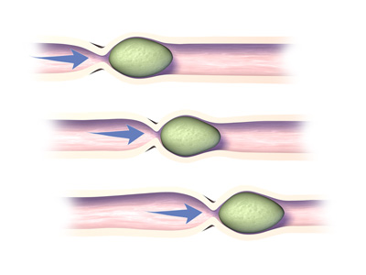
19. Define the term peristalsis and describe its role in the human body.
Peristalsis is the food moves down the esophagus due to rhythmic, muscular contractions of the smooth muscle that lines the esophagus.
a) Label the diagram using the following terms: Red blood cell, alveoli, oxygen, carbon dioxide, capillary.
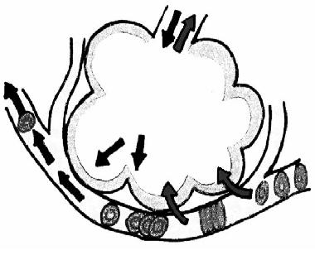

b) Explain what is happening in the diagram above and use the following terms in your explanation: Red blood cell, bronchioles, alveoli, bronchi, mouth, trachea, oxygen, carbon dioxide, transportation.
20. Explain the difference between breathing and gas exchange
Breathing includes inspiration (taking air in) and expiration (removing air) from the respiratory system from the nasal cavity (mouth and nose) down the trachea into the bronchus. The bronchus then split further like branches on a tree into bronchioles where the tips of the bronchioles are the air sacs called the alveoli. Gas exchange happens at the site of the alveoli as they are held by capillaries. Capillaries allow for blood cells to transport oxygen and carbon dioxide. When air is expired (exhaled) CO₂ is removed from the blood cells and when we inspire (inhale) the blood cells then take in O₂ from the lungs via diffusion. The two organ systems at work here are the circulatory system and the respiratory system.
21. What is the role of the epithelial tissue that lines the trachea and bronchi?
Structure and support
22. List the 3 parts that make up the circulatory system
heart, blood vessels, and blood

23. Fill in the following table
 | Structure | Function
Red Blood Cells | 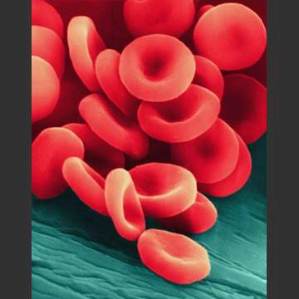 | Contain hemoglobin, a protein that picks up oxygen and carbon dioxide.
White Blood Cells | 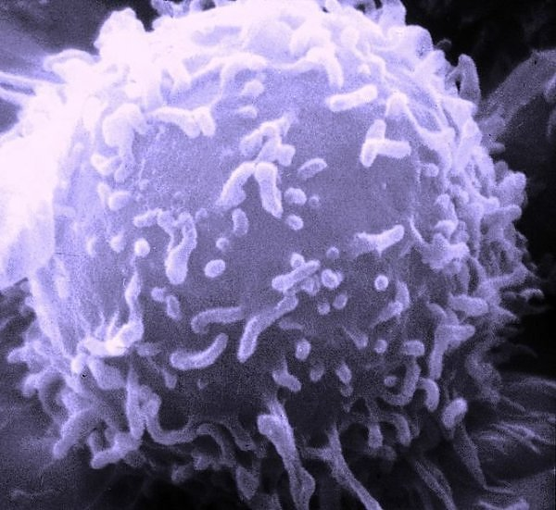 | Fight and destroy disease causing bacteria and viruses.
Platelets | 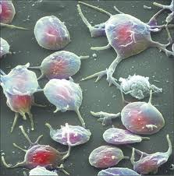 | Small cells that help blood clot, seal wounds and stop bleeding.
Plasma | 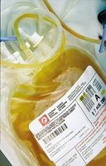 | Carries blood cells, dissolved wastes, nutrients and hormones.

24. Describe the functions of the following organ systems
 | Structure (Parts) | Function
Circulatory | Heart  Blood  Veins | - To circulate blood throughout body  - Regulate the pumping of the heart  - Facilitates the respiratory system with gas exchange
Respiratory | Mouth  Pharynx  Trachea  Bronchus  Bronchioles  alveoli | - The human respiratory system allows one to obtain oxygen, and eliminate carbon dioxide.  - Helps the give oxygen to all cells of the body needed to live
Digestive | Mouth  →(tongue and teeth)  Esophagus  Stomach  Small intestine  Large intestine  anus | - This is the organ system that takes in food, breaks it down, and removes the remaining waste from the body  - Small intestine absorbs nutrients from food needed for the body to sustain itself  - Large intestine absorbs water from the food

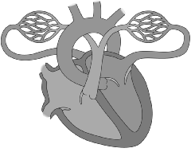
25. Structure of the Heart: Label the following parts of the human heart on the diagram below

- aorta
- left atrium
- right ventricle
- pulmonary vein (from lung)
- pulmonary artery (to lung)
- right atrium
- left ventricle
- vena cava

