Mitosis Handout Name: __________________
Mitosis is one stage of the cell cycle. Here is a diagram of the cell cycle followed by more details of mitosis. Interphase refers to the G1, S and G2 phases combined.

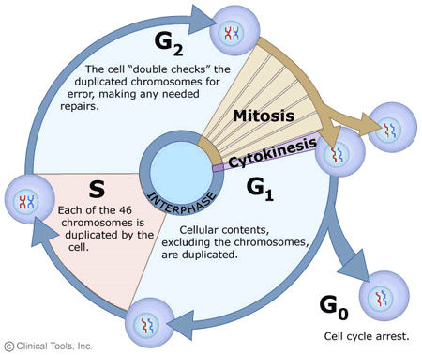

The reasons the multicellular organisms have cells that grow and divide are: (cells are called somatic cells)

The reasons that unicellular organisms grow and divide are:

Mitosis. This is only an illustration. It is important to remember what happens during every phase and subphase. Mitosis includes prophase, metaphase, anaphase and telophase.

Other important details
