Human Systems
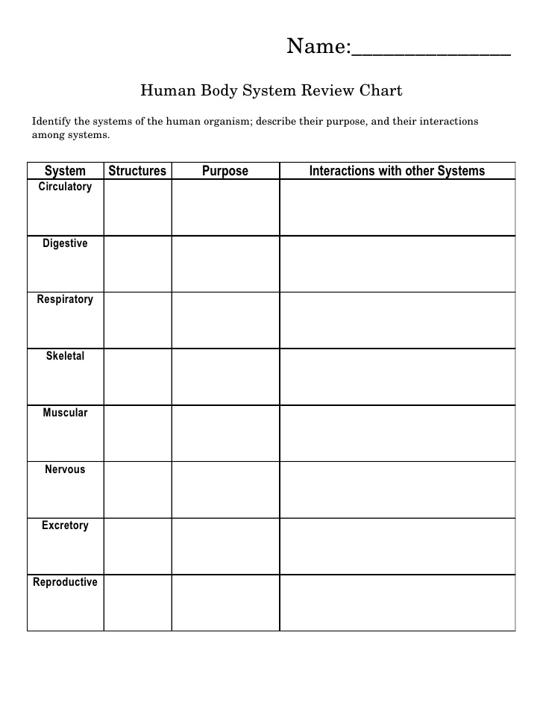
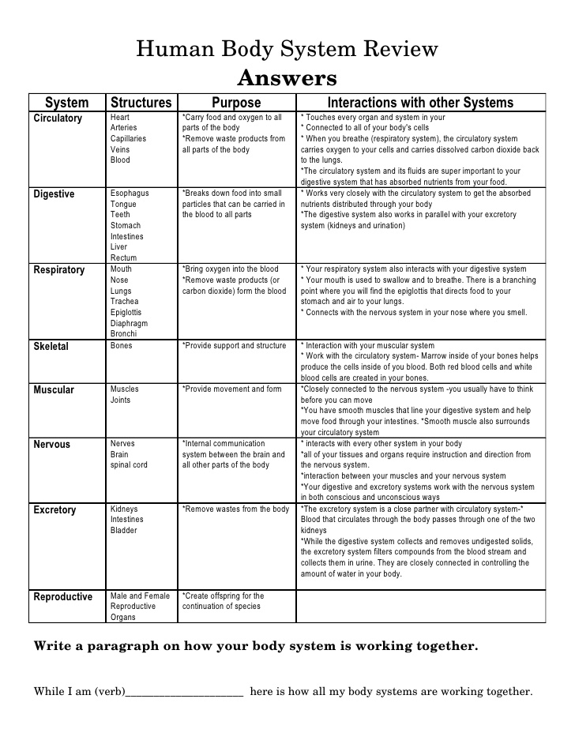

Body Systems Review Word Wraparound Name: _______________________________
- Living thing composed of only 1 cell ___________________________.
R U M T
A O N I
L N S C
U L L E
- System that results in a new human being _________________________.
T A C T
O D U I
R P UV
R E G E
- Organ system that breaks down food and absorbs nutrients _______________________.
V I S E
E T G H
A I H R
D O M C
- Living things composed of more than one cell __________________________.
L L E C
L U N I
A U L T
R M C U
- Group of organs working together to perform a specific function _____________________.
E T S Y
M S O S
A G A N
T M S I
- The only system in your body that is able to contract or shorten _______________________.
G M W A
A R U P
S L O S
D U C K
- Group of tissues working together to do a job _______________________.
J O A H
K N I G
P W R P
M H C O
- System that removes liquid waste _____________________.
Y R O T
R J R E
O X C M
T E A L
- Group of cells working together to do a job _______________.
R T E H
I L G U
N S S O
O E L P
- System that works with forces to allow body movement ______________________.
O T R A
N B A D
K M L U
L U S C
- Tissue that provides support and connects all other body parts ________________.
CE H K
I T NN
VE A O
C S M C
- Tissue that makes up the outer covering in humans ___________________.
H Z L A
T P I I
N E T L
F G H E
- System that protects and supports and also stores minerals _________________________.
B M E L
G S K E
E T TA
I N Y L
- System of glands that help regulate metabolism, growth, reproduction…_________________.
E L A N
G N S R
D H C I
W O E N
- System that transports nutrients and waste and plays a role in the immune response ________.
C U L A
R Y P T
I R O K
M C I R
- System that fights disease
M I E S
D M N C
F M U L
G E R M

